Why the Podcast is Becoming Advertising's Darling
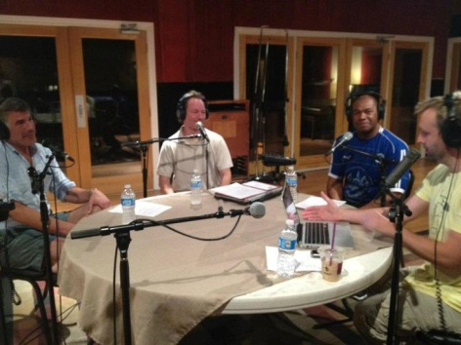
Investment in podcast advertising will rise to $659 million in 2020 from 2017's estimated $314 million, the Interactive Advertising Bureau and PwC predict, with ads read by hosts ranking as the most popular choice by brands. "When you listen to something, it's much harder to block it out than when you're looking at a number of different things," says the IAB's Anna Bager, explaining why podcasts are becoming a favorite way to connect with highly engaged consumers.
CNBC 9/6/18
https://www.cnbc.com/2018/09/06/podcasts-brands-are-set-to-double-their-ad-spend---heres-why.html
Image credit:
https://i.pinimg.com/736x/27/a5/2f/27a52fe3f23700fe898259e11c570a4b.jpg

