Why the Streaming TV Boom Is About More than Just Netflix
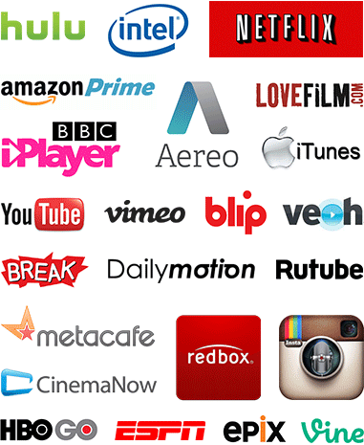
OTT platforms are disintermediating the traditional TV network value chain, bringing content owners and consumers closer, and forcing the traditional players to compete in different ways. In today’s ecosystem, everything is new: new content creators, new aggregators, new distributors, and new ways for consumers to access an ever-expanding portfolio of content.
The Wrap 7.27.16
http://www.thewrap.com/streaming-tv-boom-ott-more-than-just-netflix-guest-blog/

