Will Deep-Fake Technology Destroy Democracy?
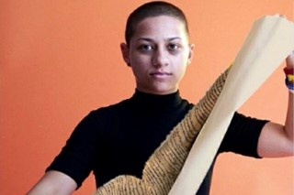
Consider the image of Emma Gonzalez, a survivor of the Parkland High School shooting in February who has become a vocal activist. A manipulated photo of her tearing up the Constitution went viral on Twitter among gun-rights supporters and members of the alt-right. The image had been digitally altered from another photo appearing in Teen Vogue.
The New York Times 10.17.18
https://www.nytimes.com/2018/10/17/opinion/deep-fake-technology-democracy.html?utm_source=API+Need+to+Know+newsletter&utm_campaign=2ba5ae33f0-EMAIL_CAMPAIGN_2018_10_18_12_25&utm_medium=email&utm_term=0_e3bf78af04-2ba5ae33f0-31697553
Image credit:
http://dazedimg.dazedgroup.netdna-cdn.com/320/0-0-1236-824/azure/dazed-prod/1230/8/1238072.jpg

