Will Voice Commerce Take Off in 2019?
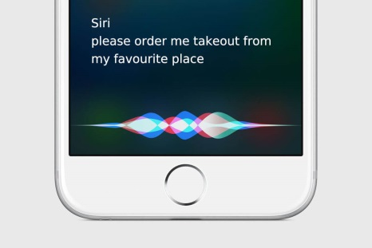
Some 58% of American internet users don't use smart speakers and aren't interested in using them to buy products, while only 2% use their smart speakers regularly to purchase from brands, Bizrate Insights reports. "Reordering is where voice commerce will gather momentum in 2019," predicts eMarketer's Andrew Lipsman.
eMarketer 2/3/19
https://www.emarketer.com/content/the-uncomfortable-state-of-voice-commerce
Image credit:
https://crazylister.com/wp-content/uploads/2018/07/apple-siri-voice-commerce-device.jpg

