Wireless Companies Slow Down Mobile Video
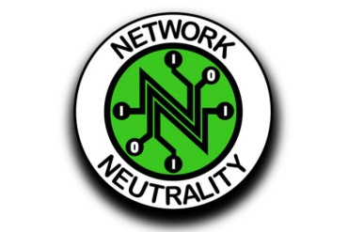
“Net neutrality violations are rampant,” states the report, issued by researchers at Northeastern University, University of Massachusetts-Amherst and Stony Brook University. They add the throttling practices they observed are creating “an unlevel playing field for video streaming providers while also imposing engineering challenges.”
MediaPost 9.8.18
https://www.mediapost.com/publications/article/327799/wireless-companies-slow-down-mobile-video.html?utm_source=Listrak&utm_medium=Email&utm_term=Wireless+Companies+Slow+Down+Mobile+Video&utm_campaign=More+3Q+Revenue+Gains+From+Scripps%2c+Tribune

