With Less Than a Week to go, the Oscars Sell Out
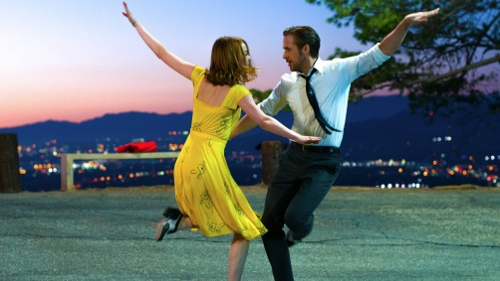
Commercial time for Sunday’s ceremony is sold out, and it went for more than last year. ABC reportedly received an average $2 million per 30-second ad, up 7 percent over $1.72 million last year. With high interest from advertisers, ABC was able to move those last few ads for $2.5 million, a huge premium on its average price.
MediaLife 2.21.17
http://www.medialifemagazine.com/less-week-go-oscars-sell/

