WKCC-FM to Shut Down By Year's End
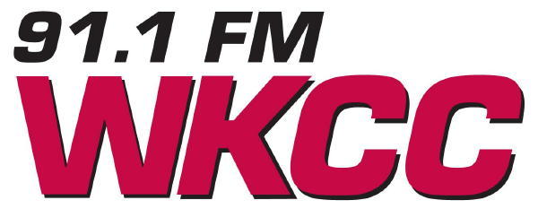
Kankakee Community College's public radio station WKCC-FM will be shutting down in approximately six months. A lack of listener/corporate funding and a decline in the college's enrollment are the reasons behind the financially-based decision. WKCC-FM has a very lean budget of $200,000, but could only raise about one third of that in listener donations and corporate funding. The school is no longer able to cover the balance needed.
Chicagoland Radio & Media 6.18.15

http://chicagoradioandmedia.com/news/7466-wkcc-fm-to-shut-down-by-year-s-end

