Women Directed 40% of Films In Festival's Platform Lineup
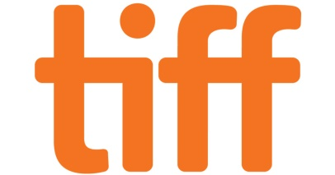
Four out of the 10 films selected by the Toronto International Film Festival for its Platform program were directed by women. The women featured in the director-based category will be Julie Delpy, Alice Winocour, Sarah Gavron and Paula Hernandez, and TIFF will be the world premiere for all four of their films.
IndieWire 8/7/19
https://www.indiewire.com/2019/08/tiff-2019-platform-lineup-1202163822/

