Women In Music Industry Still Face ‘Prevalent’ Discrimination
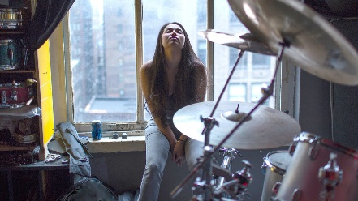
Discrimination is prevalent. Eighty-four percent of respondents had faced discrimination equally across all racial identities, 77 percent felt they had been treated differently in the music industry because of their gender and over 56 percent believed their gender had affected their employment in the industry, with music creators and performers expressing this the most, at 65 percent.
Variety 3.8.22
https://variety.com/2022/music/news/women-music-industry-discrimination-study-1235198396/#recipient_hashed=4bdea28ed7edabe80c88291efb5b43e05f6aa132f85563ea27c5fd4e048c2310
Image credit:
https://www.bing.com/images/search?view=detailV2&ccid=vC8lTlnz&id=E9ADD3BEE5DE69FF9ABB5435B6C5DFFC9467FDBA&thid=OIP.vC8lTlnzHrQk5MPT1BA24wHaEK&mediaurl=https%3a%2f%2fimg.thedailybeast.com%2fimage%2fupload%2fc_crop%2cd_placeholder_euli9k%2ch_1440%2cw_2560%2cx_0%2cy_0%2fdpr_2.0%2fc_limit%2cw_740%2ffl_lossy%2cq_auto%2fv1492177643%2farticles%2f2015%2f08%2f26%2fwomen-s-music-industry-horror-stories-abuse-sexism-and-erasure%2f150826-zimmerman-music-industry-tease_oumabk&cdnurl=https%3a%2f%2fth.bing.com%2fth%2fid%2fR.bc2f254e59f31eb424e4c3d3d41036e3%3frik%3duv1nlPzfxbY1VA%26pid%3dImgRaw%26r%3d0&exph=833&expw=1480&q=women+in+music+industry&simid=608011294532125852&FORM=IRPRST&ck=DF707976FF4B4859F680B6D3880DBC14&selectedIndex=139&ajaxhist=0&ajaxserp=0

