Women, Minorities Still Fighting Pay Inequity in TV
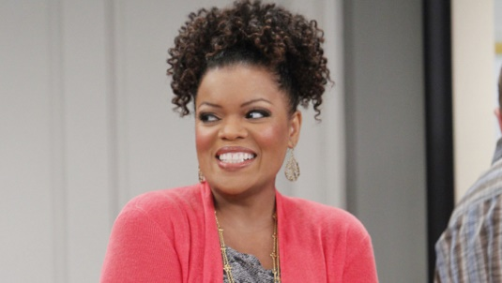
"Community" and "The Mayor" actor Yvette Nicole Brown, who found out she was earning little more than a white guest star as a series regular on an unnamed show, joins a growing list of female and minority actors detailing pay discrepancies in Hollywood. A recent analysis conducted by Variety found that of the 46 lead roles planned for new broadcast series in the upcoming TV season, only 33% of the lead roles were filled by women and 20% were cast with actors who are nonwhite or Hispanic.
Variety 8/22/17
http://variety.com/2017/tv/features/equal-pay-television-women-minorities-men-1202534339/
Image credit:
https://1.bp.blogspot.com/-rGOiOJz6uxw/VtY9P46AO8I/AAAAAAAAJm8/uwFVZJwSjk4/s1600/yvette-nicole-brown.jpg

