Women Only Get 20% of Roles After the Age of 40
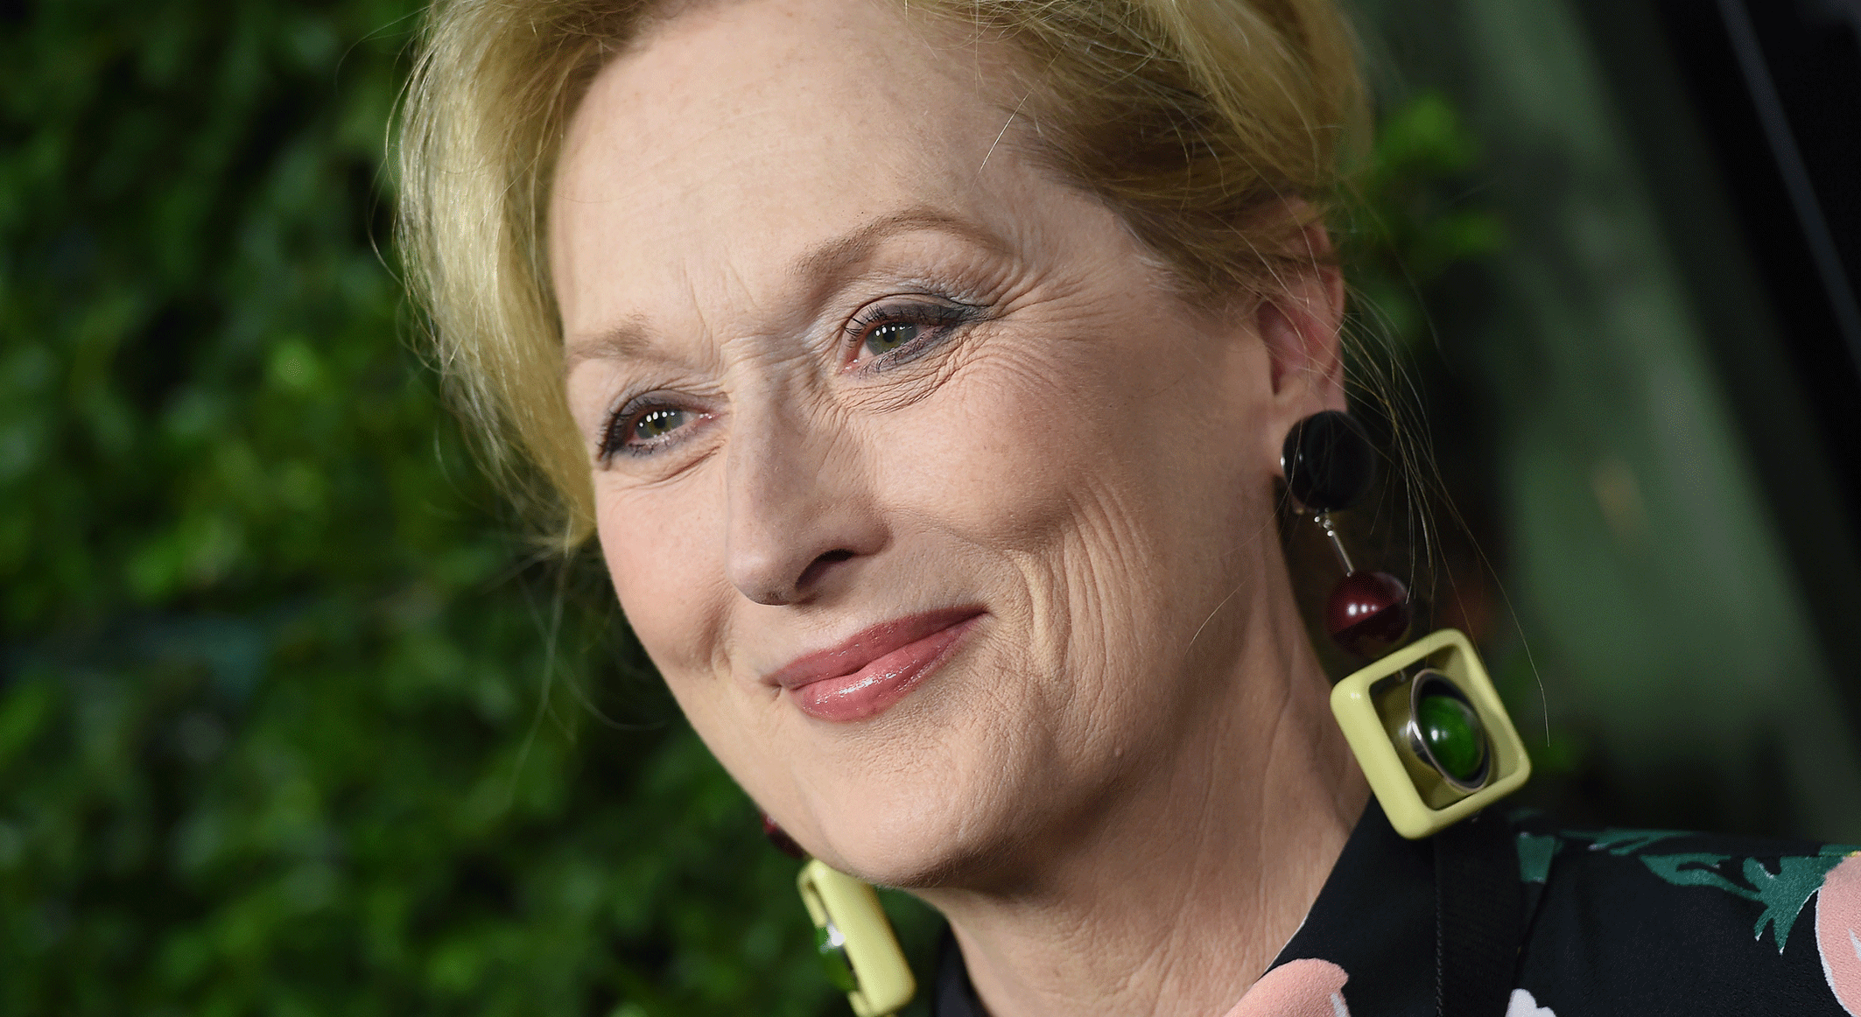
Turning 40 in Hollywood is more detrimental for female actors than male actors, shows new data compiled by Robert Fleck and Andrew Hanssen. Statistics from IMDB revealed that in addition to claiming two-thirds of all leading roles, men over 40 also get 80% of film roles compared to women, who only get 20% of roles once they turn 40. "This is a key thing -- women have shorter careers that start earlier," Fleck said of the findings.
The Washington Post 9/19/16
https://www.washingtonpost.com/news/wonk/wp/2016/09/19/these-charts-reveal-how-bad-the-film-industrys-sexism-is/
image source:
https://www.bing.com/images/search?q=meryl+streep+ROLES&view=detailv2&&id=D3F937829627F4C0D8E6CE3A219B1C2D25924220&selectedIndex=78&ccid=XIMo1WDO&simid=608012296194230030&thid=OIP.M5c8328d560ce6335d0b25a18df80e5aco1&ajaxhist=0

