YouTube's Mohan Points to 3 Digital Video Trends
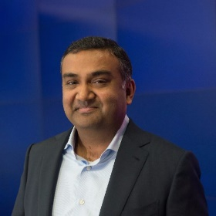
Continued growth in digital video consumption will be driven this year by connected TV, short-form content and shopping via video, YouTube Chief Product Officer Neal Mohan said during the IAB Annual Leadership Meeting (ALM). Mohan said YouTube is focused on building on its CTV momentum and pointed to the value in integrations with Nielsen tools for ad measurement.
MediaPost Communications 3/10/21
https://www.mediapost.com/publications/article/361278/youtubes-mohan-touts-trends-redefining-video-ads.html
Image credit:
https://pbs.twimg.com/profile_images/828000453136875522/93iQx_Gs.jpg

