YouTube TV Is Now the 5th Largest Pay TV Operator with 5.7 Million Subs
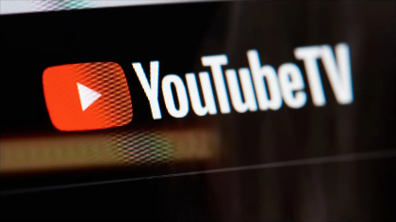
Leichtman Research Group believes the Google vMVPD added 100,000 customers in Q1, making it the only U.S. operator that grew during the quarter.
Next TV 5/16/23
https://www.nexttv.com/news/youtube-tv-is-now-the-5th-largest-pay-tv-operator-with-57-million-subs-estimate?utm_term=A25693A1-51B6-4112-BDE4-56BD420E983F&utm_campaign=C74FC4FA-5D4D-4151-8915-3043BA411DBE&utm_medium=email&utm_content=C8417DB4-76E7-4FE4-937F-7B6B8B8FA68A&utm_source=SmartBrief
Image credit:
https://www.howtogeek.com/wp-content/uploads/2021/08/youtube-tv-logo-on-screen.jpg?width=1198&trim=1,1&bg-color=000&pad=1,1

