YouTube TV: Covering 98% of the U.S.
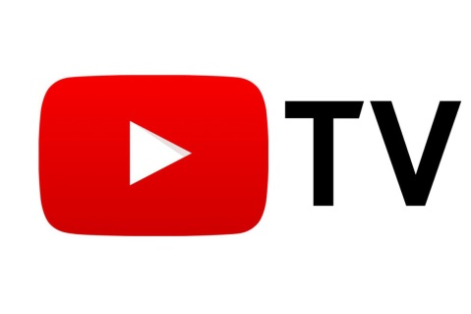
Starting Wednesday, the streaming multichannel video service, which includes linear broadcast and cable channels, as well as on-demand content, is nearly doubling the number of markets where it's available.
MediaPost 1.23.19
https://www.mediapost.com/publications/article/330981/youtube-tv-expands-nationwide-covering-98-of-the.html?utm_source=Listrak&utm_medium=Email&utm_term=YouTube+TV+Expands+Nationwide&utm_campaign=Nielsen+Wants+To+Sell+Itself%2c+Could+Fetch+%2410B

