YouTube TV Takes Platform Spotlight With 8M-Plus Accounts
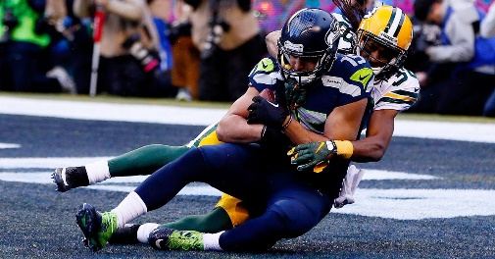
YouTube TV's exclusive NFL deal "really shows the future of YouTube," said YouTube leader Neal Mohan, who also reported that the platform's TV service has at least 8 million accounts. Mohan also plans to focus YouTube's efforts on adding artificial intelligence and developing a supportive environment for creators.
Tubefilter 2/6/24
https://www.tubefilter.com/2024/02/06/youtube-neal-mohan-creator-letter-2024/
Image credit:

