Ziff Davis Buys Mashable On the Cheap
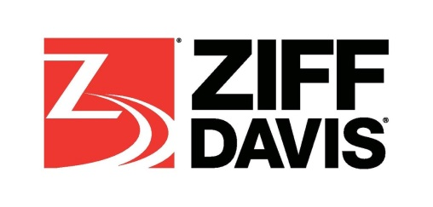
Sometimes it’s better to buy than build. That’s the real takeaway from Ziff Davis acquiring Mashable. A deal that’s reportedly worth $50 million. When you hear a number like that you don’t necessarily think fire sale, but in Mashable’s case it’s a deep discount from where the company was a year or two ago. How quickly the tables can turn.
Folio 11.20.17
http://www.foliomag.com/ziff-davis-buys-mashable-on-the-cheap/

