Zuckerberg Details Vision, Boosts Consumers Ad Controls
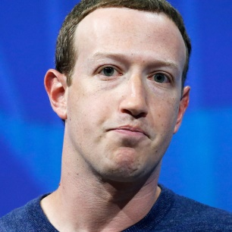
Facebook CEO Mark Zuckerberg outlined a manifesto and five areas of focus he deems critical for the platform and society, which include advancements in augmented and virtual reality, a private social platform, facilitating small businesses and online payments, and one set of rules for tech platforms. Zuckerberg also maintained his stance on accepting political ads, but the platform will be giving consumers more control via its Custom Audience list.
Marketing Land 1.9.20
https://marketingland.com/facebook-to-roll-out-new-user-controls-centered-on-custom-audience-list-data-274026
Image credit:
https://pixel.nymag.com/imgs/daily/vulture/2018/06/15/15-mark-zuckerberg.w700.h700.jpg

